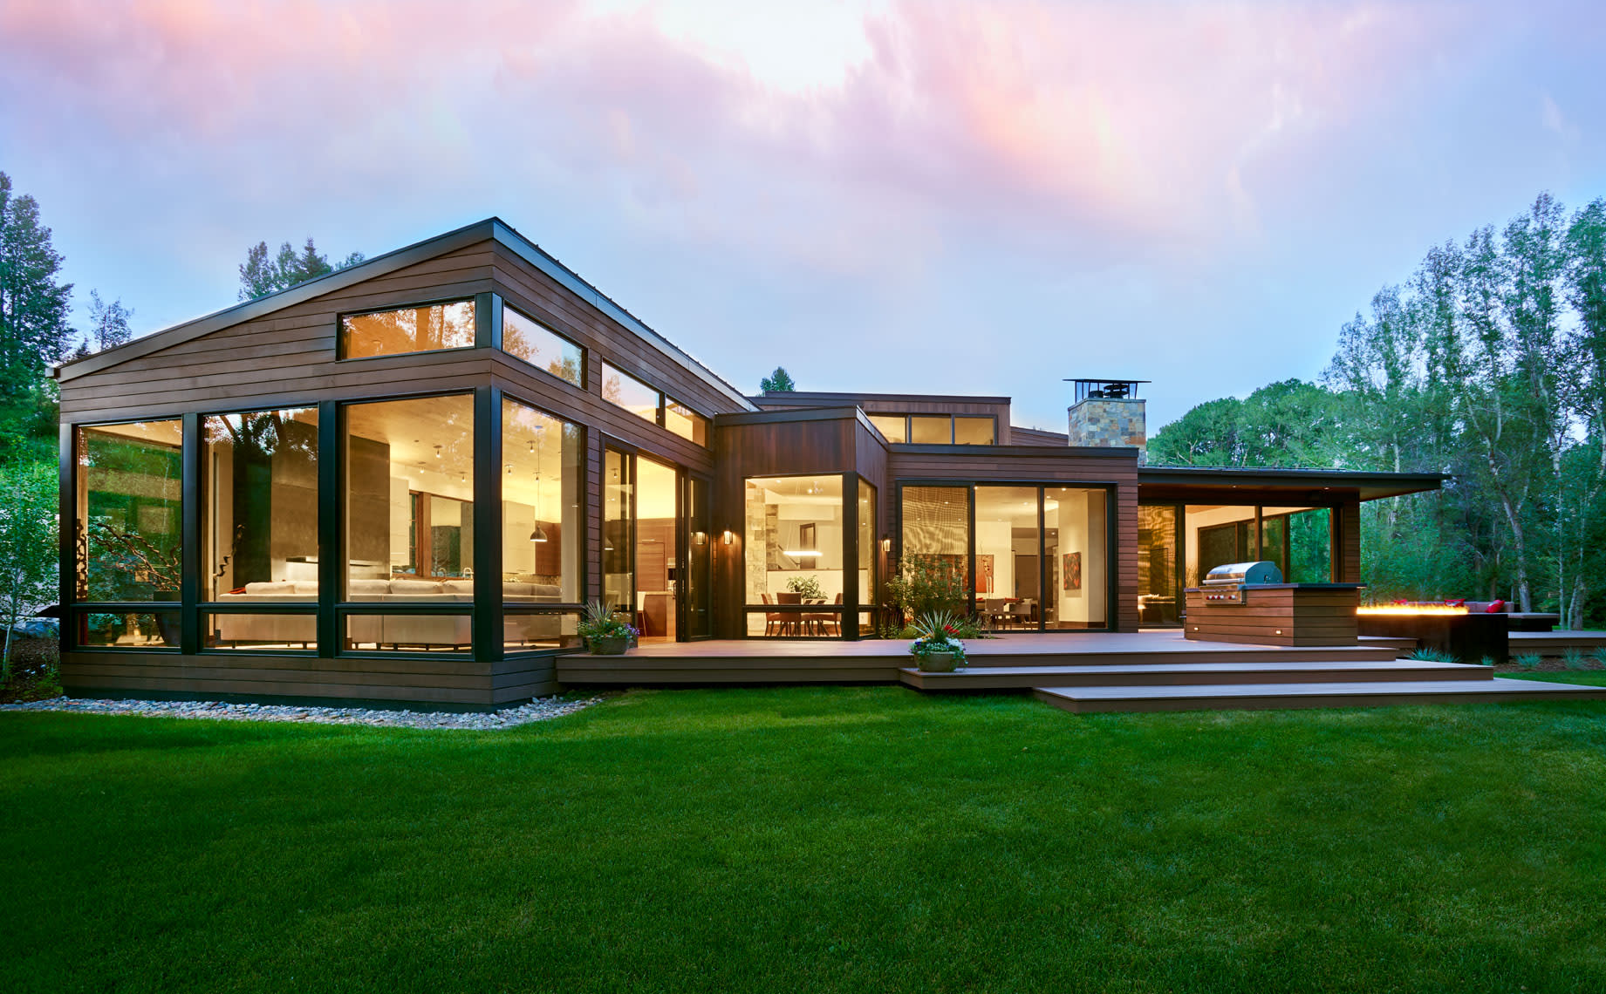

**Building Survey**

10 High Street

Anytown

YJ7 8KL

August 2023

Surveyed By: John Smith

# 

Table of Contents

1. Introduction 3

2. General description of the property 4

3. External condition of the property 5

4. Typical House Diagram 7

# Introduction

This Building Survey is produced by an RICS surveyor who has written this report for you to use. If you decide not to act on the advice in this report, you do this at your own risk. The Building Survey aims to:

* help you make a reasoned and informed decision when purchasing the property, or when planning for repairs, maintenance or upgrading of the property
* provide detailed advice on condition
* describe the identifiable risk of potential or hidden defects
* where practicable and agreed, provide an estimate of costs for identified repairs
* make recommendations as to any further actions or advice which need to be obtained before committing to purchase.

No below ground investigations have been carried out and no drainage survey has been undertaken.

# General description of the property

The property is a detached, two storey chalet type house believed to have been constructed circa.1980. The main roof is pitched and covered with plain concrete tiles. The elevations have been constructed in reconstituted cavity stonework finished in part with uPVC panelling.

The floors are a mixture of solid and suspended timber construction. There is an integral garage to the right hand side of the property.

The property has front and rear gardens. The front garden area is open plan with a driveway and the rear garden area is private and enclosed.

The property is accessed via an unadopted road.

# External condition of the property

In this section of our report, we summarise the defects noted and principal concerns regarding the external condition of the property.

**Front Elevation**

The roof covering is in a serviceable condition with no significant slippage or deterioration of the tiles noted. Several tiles to the left hand side of the main roof were noted to be damaged, requiring replacing in the immediate term.

|  |  |
| --- | --- |
| Photo 1 | Photo 2 |

The bedding mortar to the ridge tiles is in good condition with the tiles firmly bedded into position.

Where the forward facing dormer roofs abuts the main roof, tiled valleys have been formed which are noted to be relatively blocked with vegetation requiring clearing in the immediate term. It should be noted that it is necessary to keep the valleys clear of debris to prevent rainwater backing up into the roof void.

|  |  |
| --- | --- |
| Photo 3 |  |

The ridge line is straight and roof surface flat. A general build-up of moss was noted to the roof surface which we would advise is removed as part of the proactive maintenance scheme for the property.

# Typical House Diagram

